**ASSIGNMENT 2 FRONT SHEET**

|  |  |  |  |
| --- | --- | --- | --- |
| **Qualification** | **TEC Level 5 HND Diploma in Computing** | | |
| **Unit number and title** | **Unit 04: Database Design & Development** | | |
| **Submission date** | 04/05/2022 | **Date Received 1st submission** | 04/05/2022 |
| **Re-submission Date** | 04/05/2022 | **Date Received 2nd submission** | 04/05/2022 |
| **Student Name** | Bùi Hương Linh | **Student ID** | GBH200662 |
| **Class** | GCH1002 | **Assessor name** | Hàn Minh Phương |
| **Student declaration**  I certify that the assignment submission is entirely my own work and I fully understand the consequences of plagiarism. I understand that making a false declaration is a form of malpractice. | | | |
|  |  | **Student’s signature** |  |

**Grading grid**

|  |  |  |  |  |  |  |  |  |  |
| --- | --- | --- | --- | --- | --- | --- | --- | --- | --- |
| P2 | P3 | P4 | P5 | M2 | M3 | M4 | M5 | D2 | D3 |
|  |  |  |  |  |  |  |  |  |  |

|  |  |  |
| --- | --- | --- |
| **❒ Summative Feedback: ❒ Resubmission Feedback:** | | |
| **Grade:** | **Assessor Signature:** | **Date:** |
| **Signature & Date:** | | |

Table of Contents

Chapter 1 - Develop the database system 5

1. Final Mock-up of the application 5

2. Queries to create database with results 9

Chapter 2 – Produce queries 17

1. Queries to INSERT data with illustrations of final result 17

2. Queries to UPDATE data with illustrations of final result 26

3. Queries to DELETE data with illustrations of final result 29

4. Queries to SELECT data with illustration of final result 31

Chapter 3 – Test the system 39

1. Test cases 39

2. Flowchart to show how the system works 41

Figure 1: Interfaces Home page 5

Figure 2: Interfaces Login 6

Figure 3:Interface Product 7

Figure 4: Interface Invoice 8

Figure 5: Create Database 9

Figure 6: Show database on toolbar 10

Figure 7: Create table Customer 11

Figure 8: Create table Staff 12

Figure 9: Create table Product 13

Figure 10: Create table Invoice 14

Figure 11: Create table InvoiceDetails 15

Figure 12: Show all panels in toolbar 16

Figure 13: Queries to INSERT Customer 17

Figure 14: Show all Customer table data 18

Figure 15: Queries to INSERT Staff 19

Figure 16: Show all Staff table data 19

Figure 17: Queries to INSERT Product 20

Figure 18: Show all Product table data 21

Figure 19: Queries to INSERT Invoice 22

Figure 20: Show all Invoice table data 23

Figure 21: Queries to INSERT InvoiceDetails 24

Figure 22: Show all InvoiceDetails table data 25

Figure 23: Queries to Update 26

Figure 24: Result 27

Figure 25: Display information when changes 28

Figure 26: Display information before 29

Figure 27: Display information when changes 30

Figure 28: Select 31

Figure 29: Select * 32

Figure 30: Select ... like 33

Figure 31: Select ... where 33

Figure 32: Select ... top 34

Figure 33: Select ... group by 35

Figure 33: Select ... group by 36

Figure 33: Select ... group by 37

Figure 34: Select... having 38

Figure 35: Trigger 38

# Chapter 1 - Develop the database system

1. Final Mock-up of the application

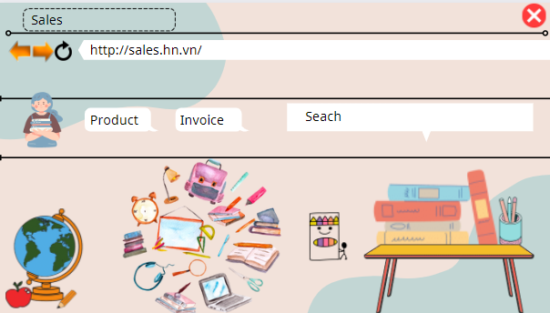

Figure 1: Interfaces Home page

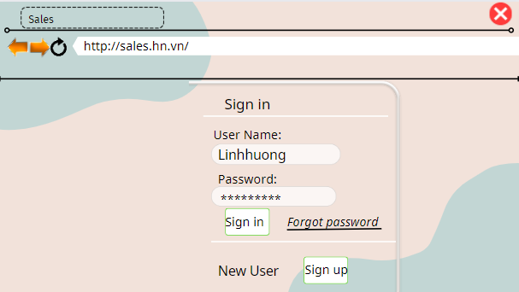

Figure 2: Interfaces Login

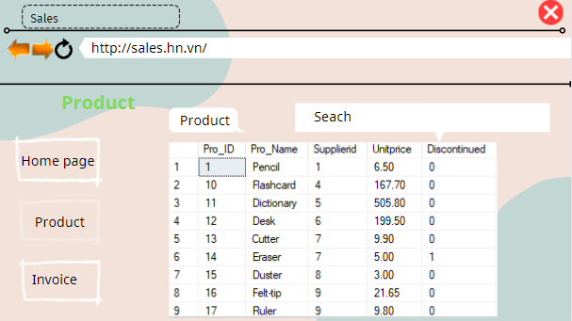

Figure 3:Interface Product

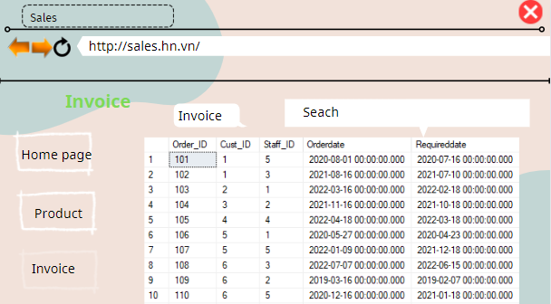

Figure 4: Interface Invoice

1. Queries to create database with results

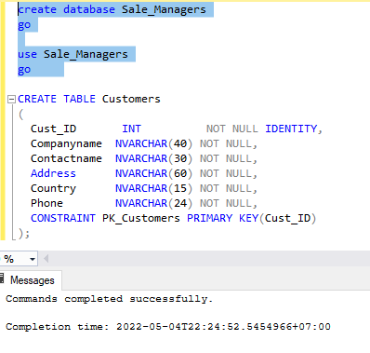

Figure 5: Create Database

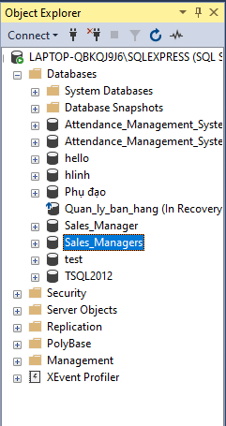

Figure 6: Show database on toolbar

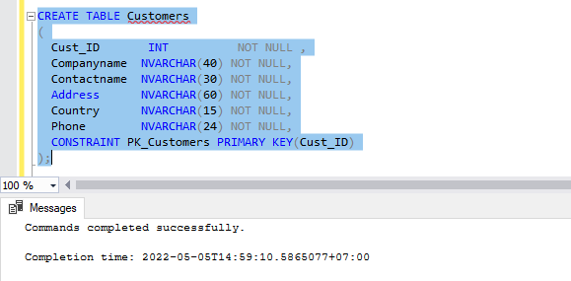

Figure 7: Create table Customer

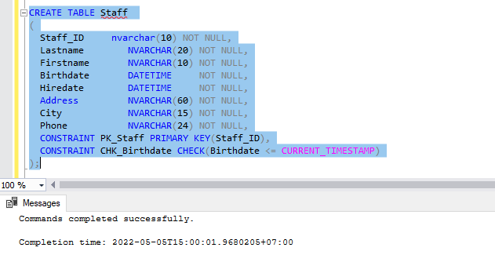

Figure 8: Create table Staff

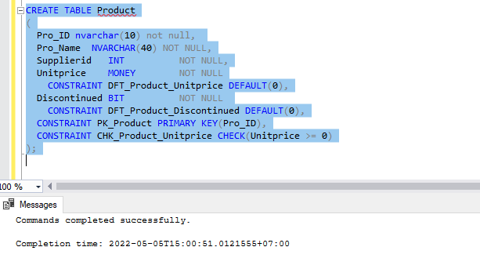

Figure 9: Create table Product

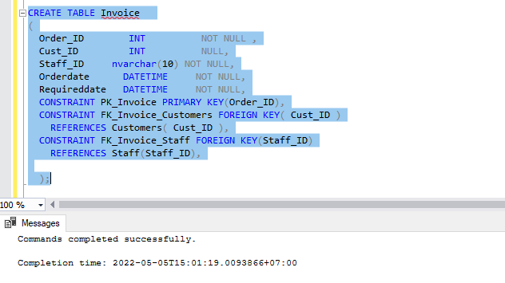

Figure 10: Create table Invoice

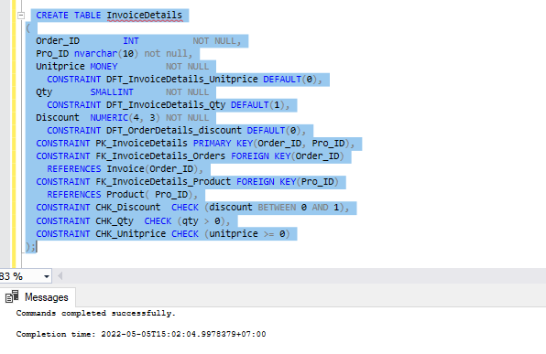

Figure 11: Create table InvoiceDetails

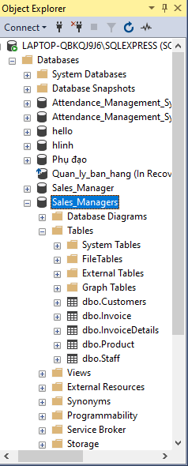

Figure 12: Show all panels in toolbar

# Chapter 2 – Produce queries

1. Queries to INSERT data with illustrations of final result

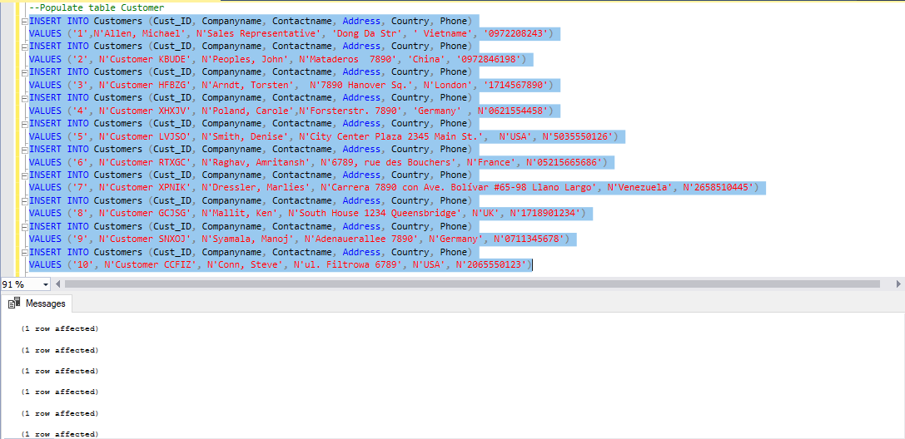

Figure 13: Queries to INSERT Customer

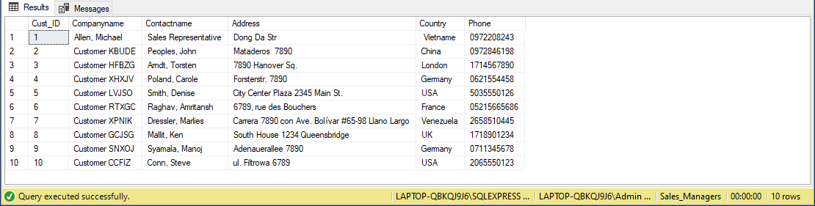

Figure 14: Show all Customer table data

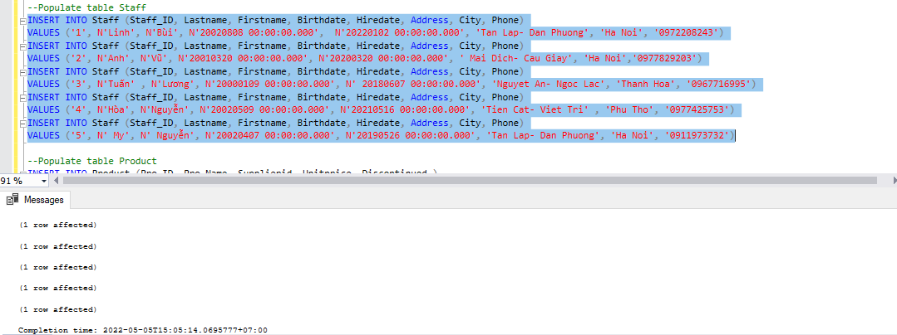

Figure 15: Queries to INSERT Staff

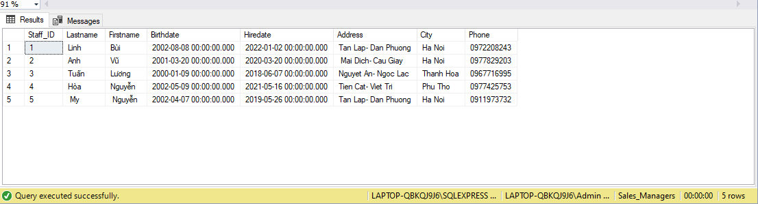

Figure 16: Show all Staff table data

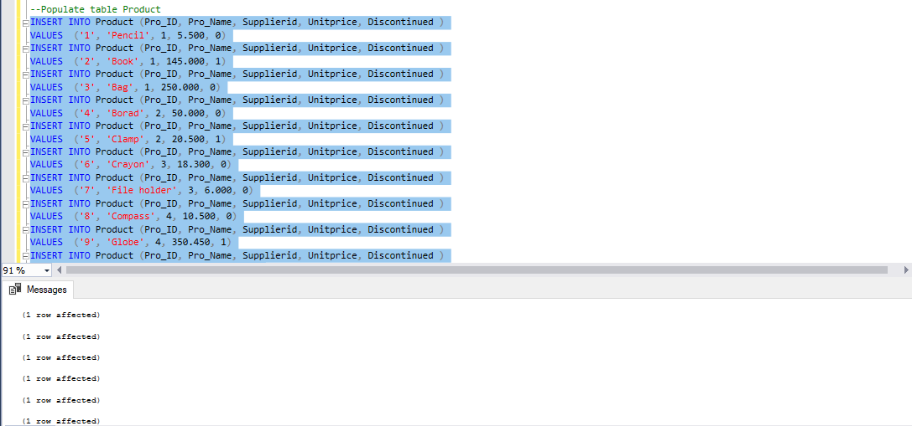

Figure 17: Queries to INSERT Product

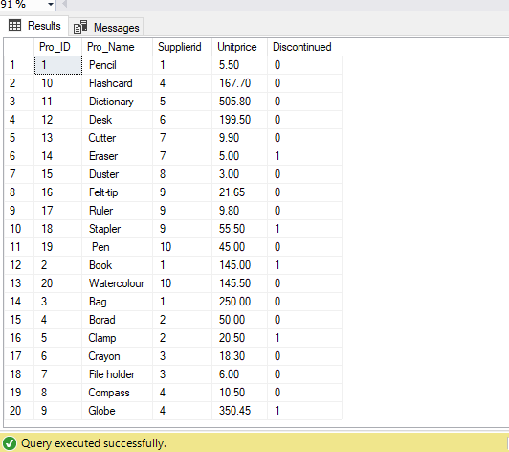

Figure 18: Show all Product table data

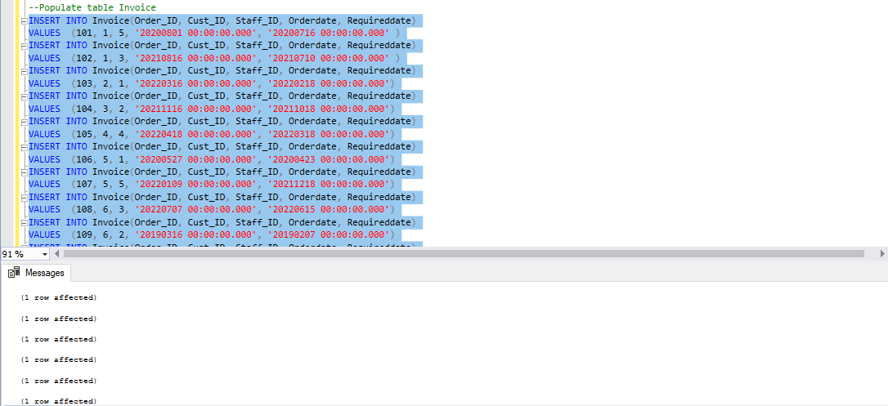

Figure 19: Queries to INSERT Invoice

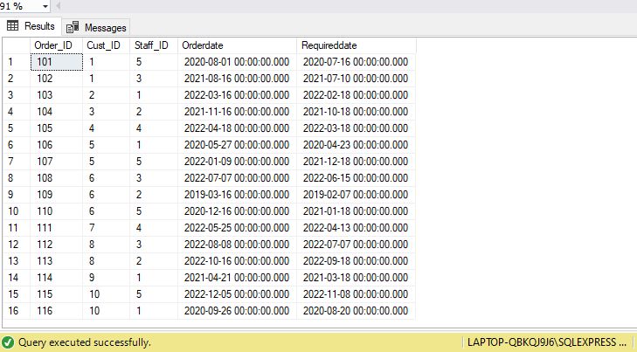

Figure 20: Show all Invoice table data

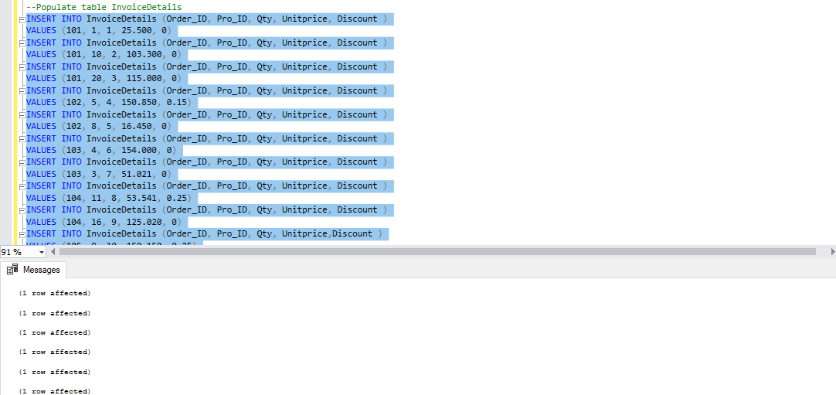

Figure 21: Queries to INSERT InvoiceDetails

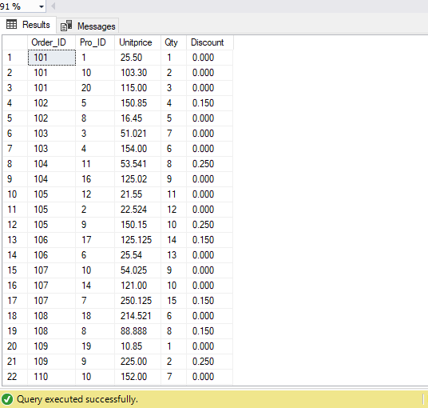

Figure 22: Show all InvoiceDetails table data

1. Queries to UPDATE data with illustrations of final result

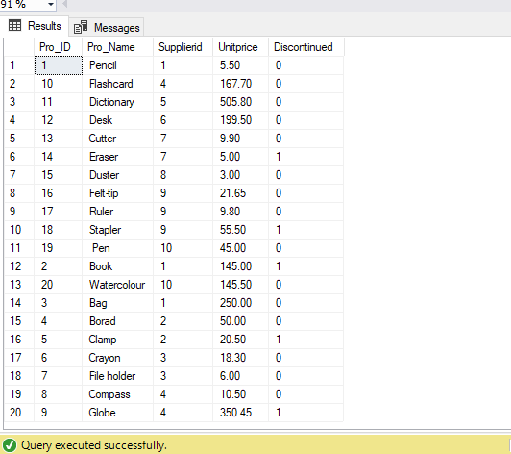

Figure 23: Queries to Update

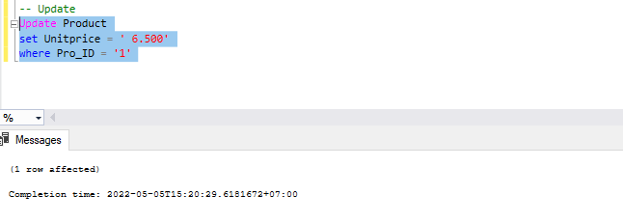

Figure 24: Result

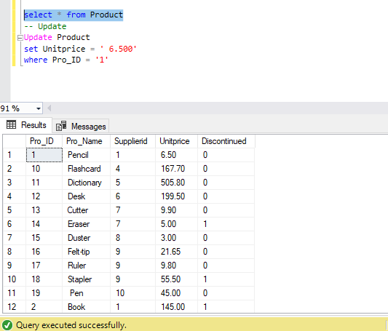

Figure 25: Display information when changes

1. Queries to DELETE data with illustrations of final result



Figure 26: Display information before

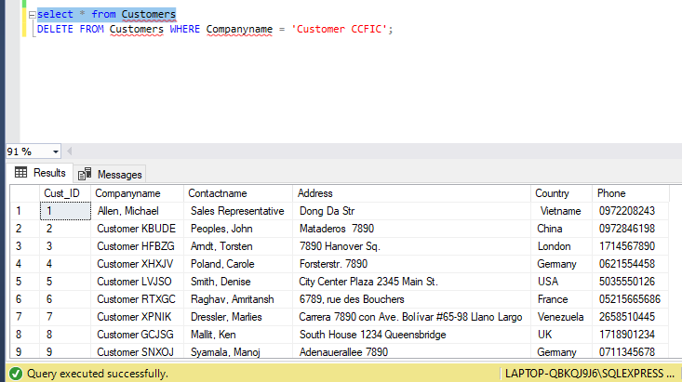

Figure 27: Display information when changes

1. Queries to SELECT data with illustration of final result

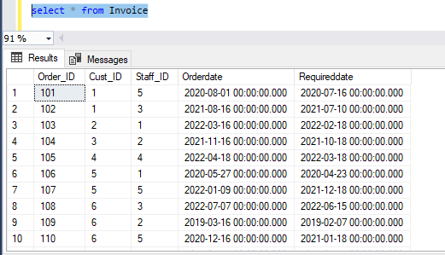

Figure 28: Select

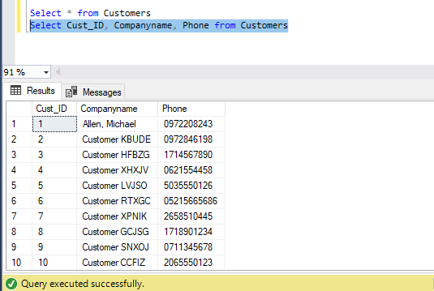

Figure 29: Select *

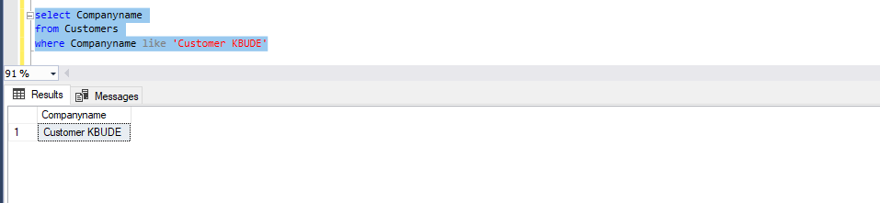

Figure 30: Select ... like

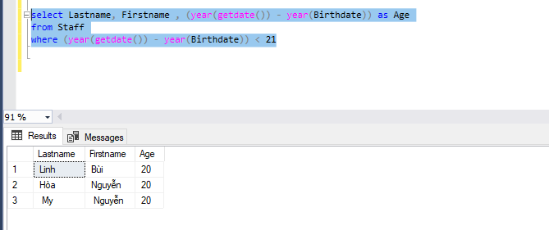

Figure 31: Select ... where

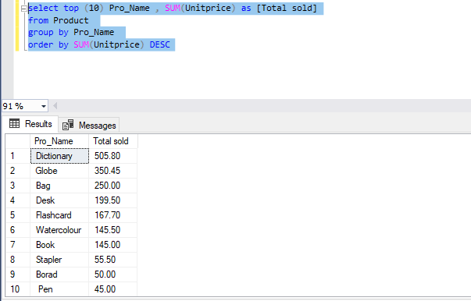

Figure 32: Select ... top

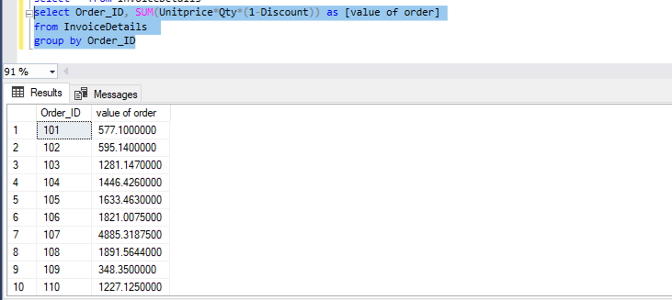

Figure 33: Select ... group by

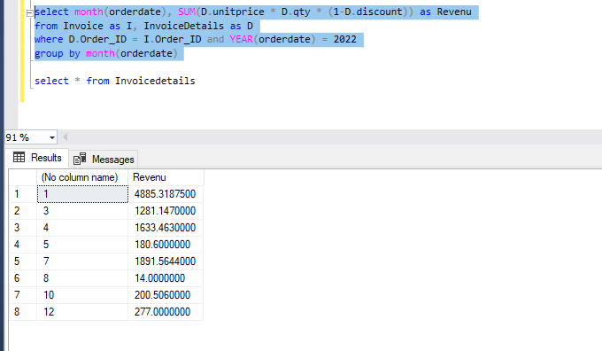

Figure 34: Select ... group by

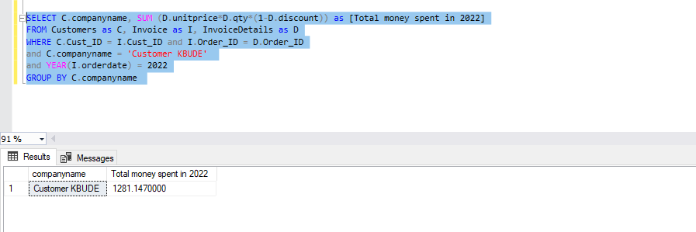

Figure 35: Select ... group by

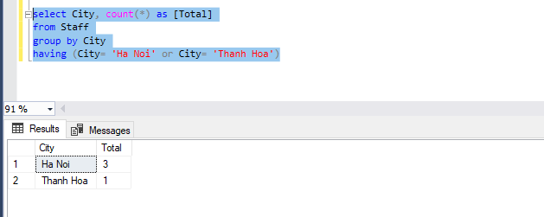

Figure 36: Select... having

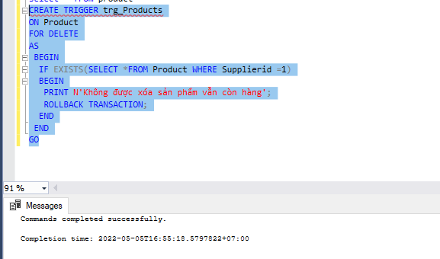

Figure 37: Trigger

# Chapter 3 – Test the system

1. Test cases

|  |  |  |  |  |
| --- | --- | --- | --- | --- |
| Test case type | Description | Test step | Expected | Status  (P/F) |
| Insert into | There is no need to specify column names because all column values are in table column order. | Using the following queries, I filled in the information in the order of the columns and inserted the data. | The new data values are stored in the database. | P |
| Update | It includes a SET clause, which defines the column and value as a pair of items. To limit the number of rows, it is necessary to use the where clause to locate the row to be modified in the table. | Change the data of the Unitprice column in Product for all rows of the table with the value of 5.500 in Pro_ID = '1' to the current 6.500 | Saw that the Unitprice column at Pro_ID = '1' was changed with  the new values. | P |
| Delete | DELETE queries include a condition in the WHERE clause because if it is not used, all records in the table are deleted. | Enter the DELETE statement to delete Companyname = 'Customer CCFIC' in the Customer table. | Companyname = 'Customer CCFIC' has been deleted. | P |
| Select * from | The query returned the full set of rows, columns, or a subset of rows and columns from one or more system Manager tables. | FROM is used to list the necessary tables used in the query. | Executing the SELECT* FROM Customer (Cust_ID, Companyname, Phone) statement outputs all columns of data. | P |
| Select top | The TOP(10) return clause inserted the first 10 rows from the result set based on Pro_Name. | TOP(10) has inserted the top 10 and is already sorted. | Will retrieve the first Pro_Name record on the table . | P |
| SQL having | Limit the sum results to limit the groups of returned rows to the group of returned rows, only if the TRUE condition for City is met to filter the results so that only addresses in Ha Noi and Thanh Hoa are returned about. | When using the HAVING clause, it must be combined with the Group by clause. Print to screen error. | Returns the result (2 rows affected) | P |
| SQL where | Filter record from tables to satisfy all system and user requiements | The operators between, >, like, can be used. | Data has been returned | P |
| SQL trigger | Delete the information of the Product table, then records the information of these changes. | Delete Products information into the table, and when the delete is complete, a successful message will be printed on the screen. All Trigger creation BEGIN and ending with END | Message: Commands completed successfully  (1 rows affected ) | P |

1. Flowchart to show how the system works

False

True

True

Admin

Invoice

Product

Product

Sales Manager interface

Login

Home page

Staff